**Deploying Node.js Based API Using AWS Lamda – Assignment**

**Process:**

**Set Up AWS Resources**

1. First step is to create a Lambda function as below :

Function name : firstcode

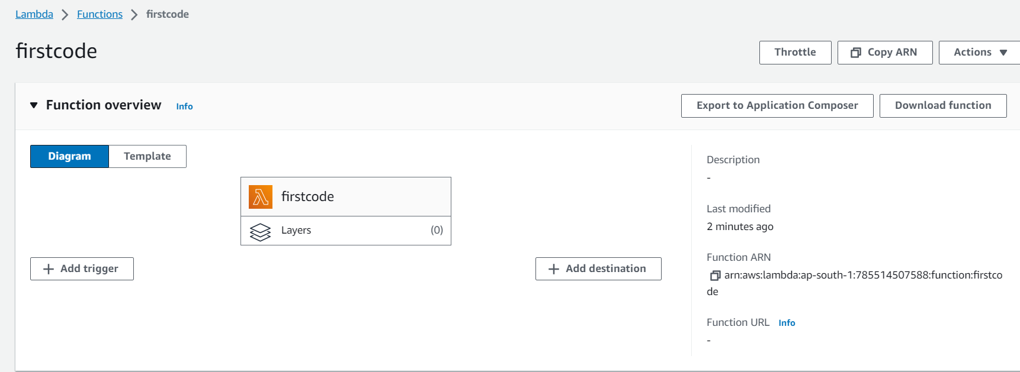

**Code file : Index.js**

Simple node.js based code base

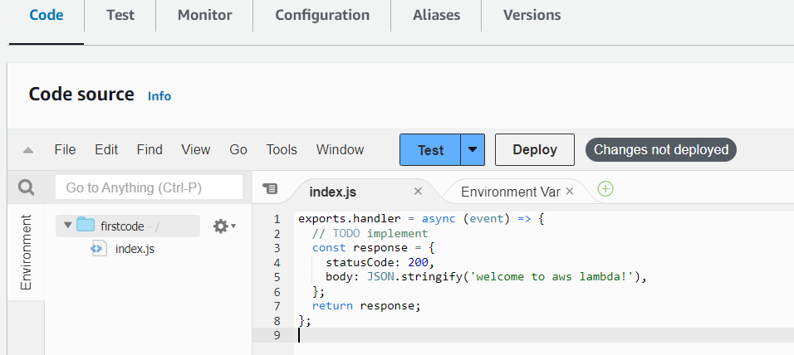

**Process of creating Event :**

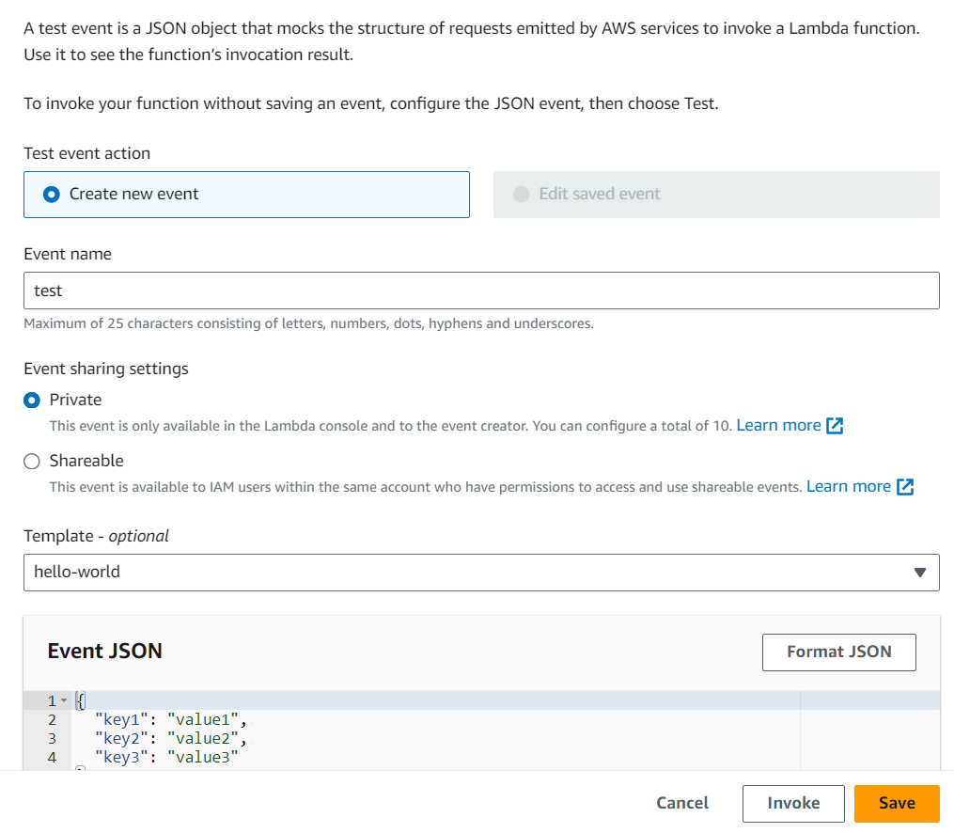

**After writing code we need to test it and we got successful result as below:**

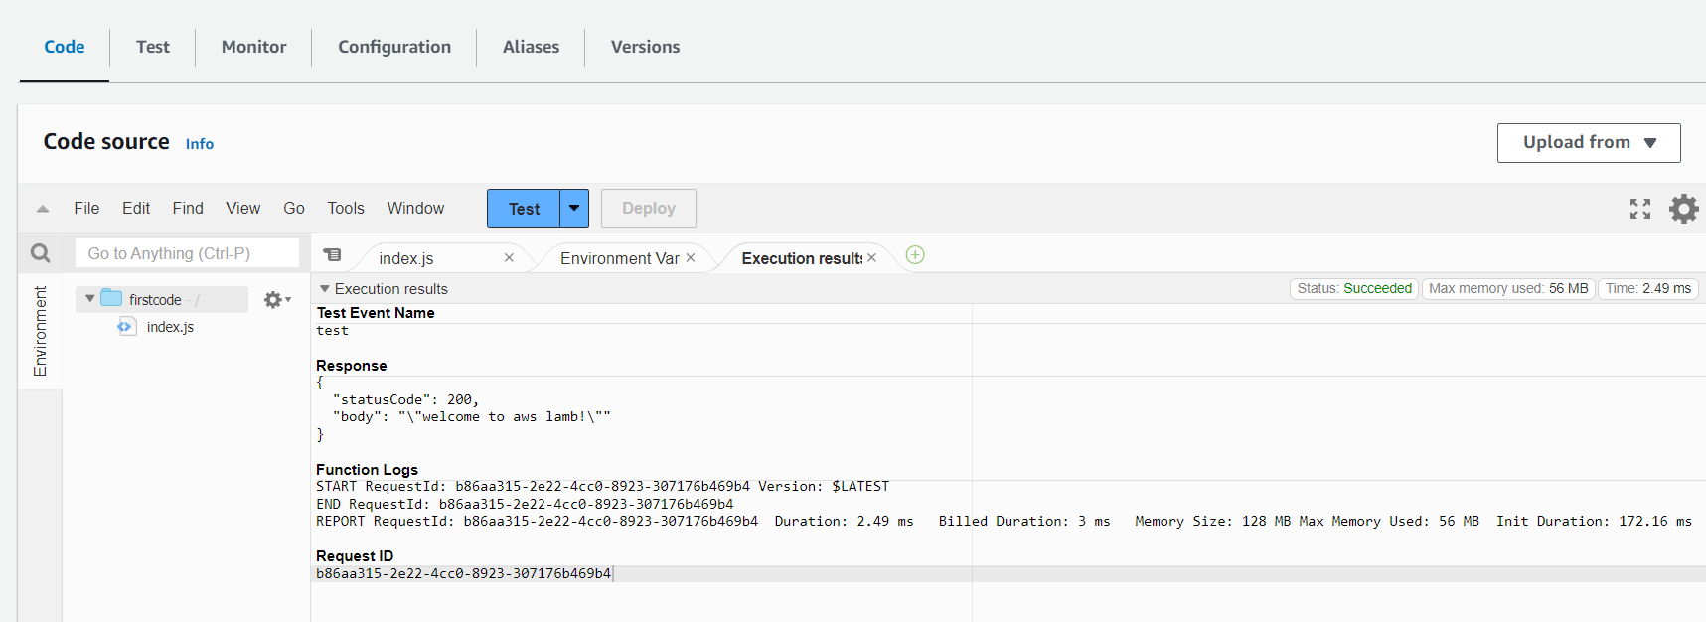

**Executing function : succeeded**

**Statuscode : 200**

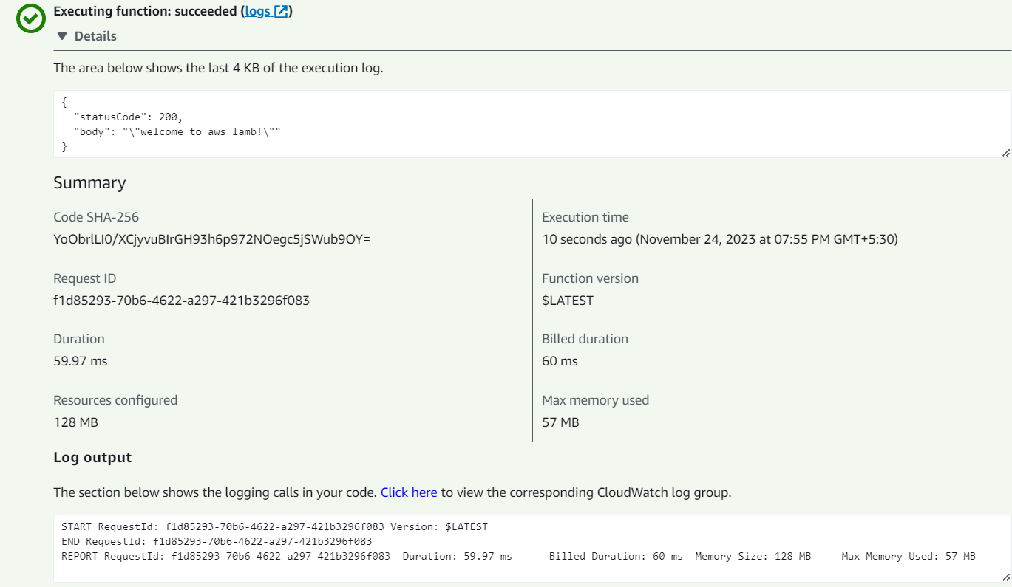

**Also we can monitor the function using the cloudwatch logs as below:**

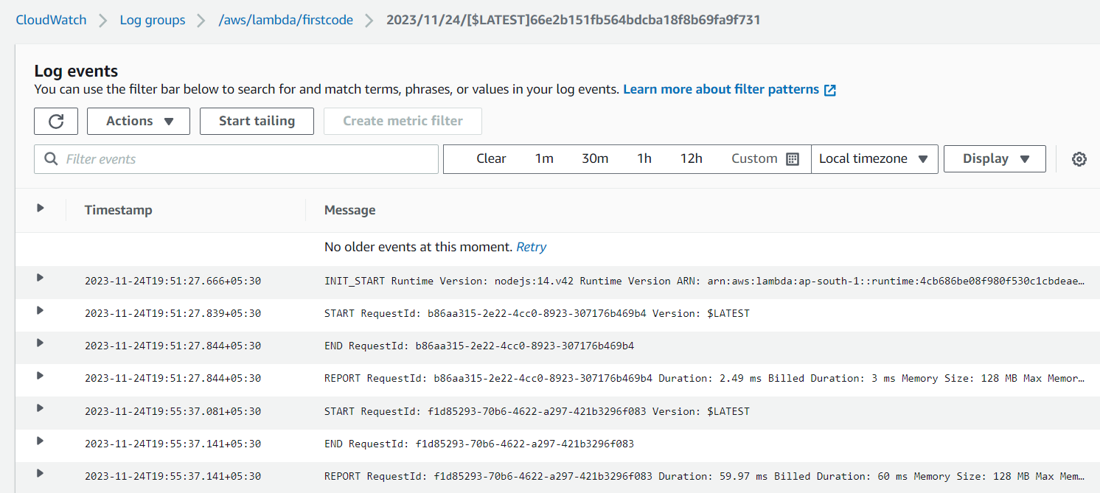

**Next step is to create a Rest using API Gateway service of AWS:**

**Rest Api name : First rest api**

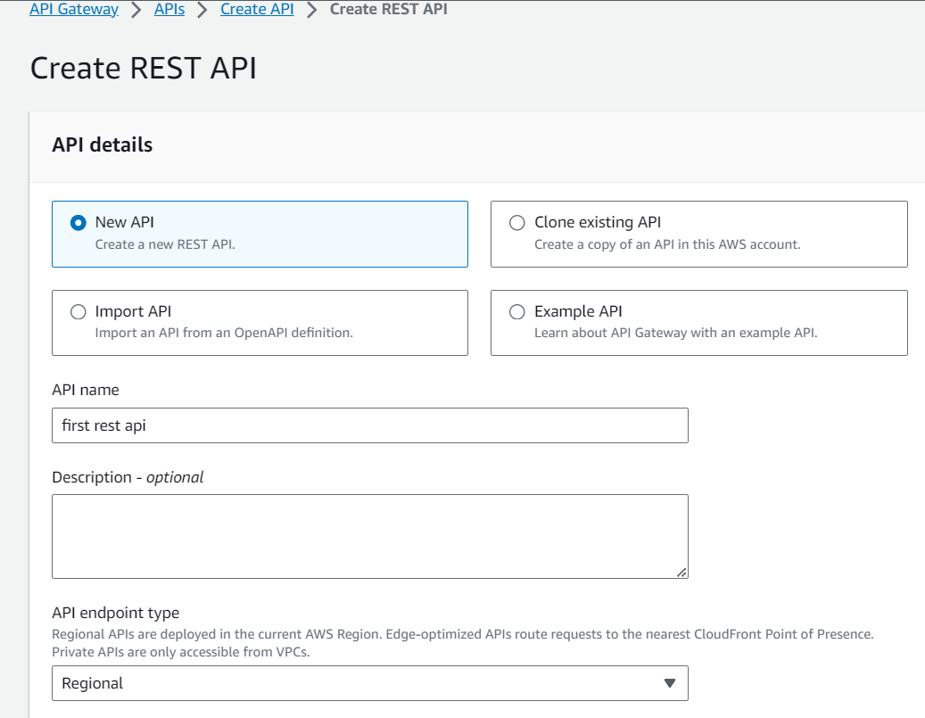

**After creation of rest api need to create a resource from it as below:**

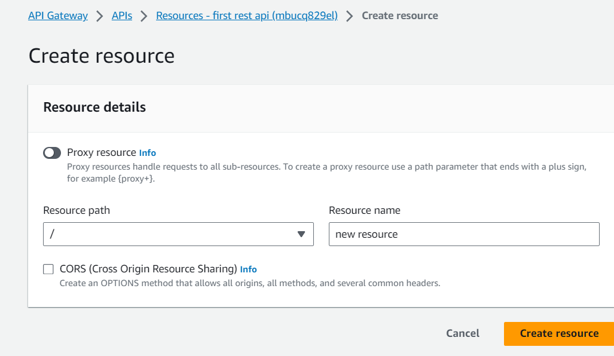

**And add method inside the resource :**

**Here we added the GET Method as below:**

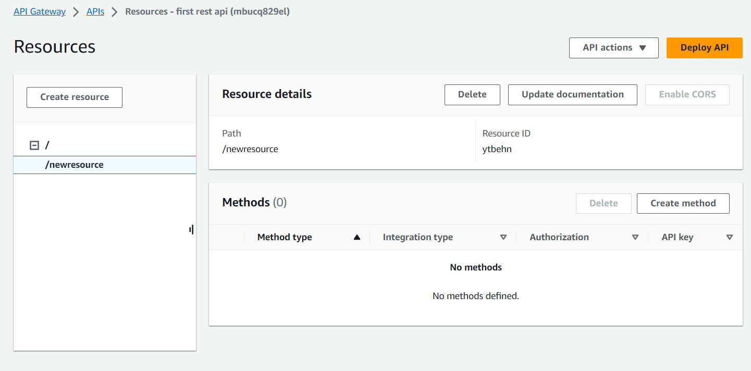

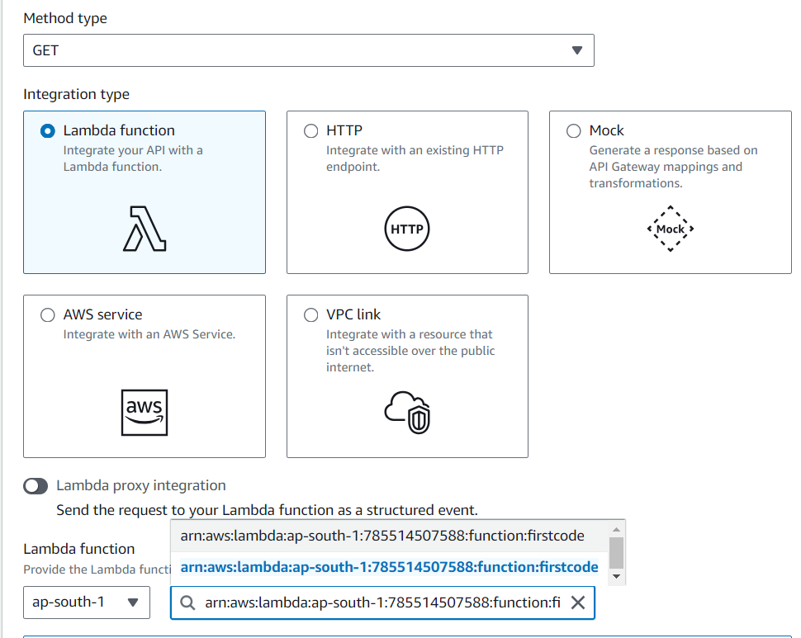

**Now next step is to deploy API as below:**

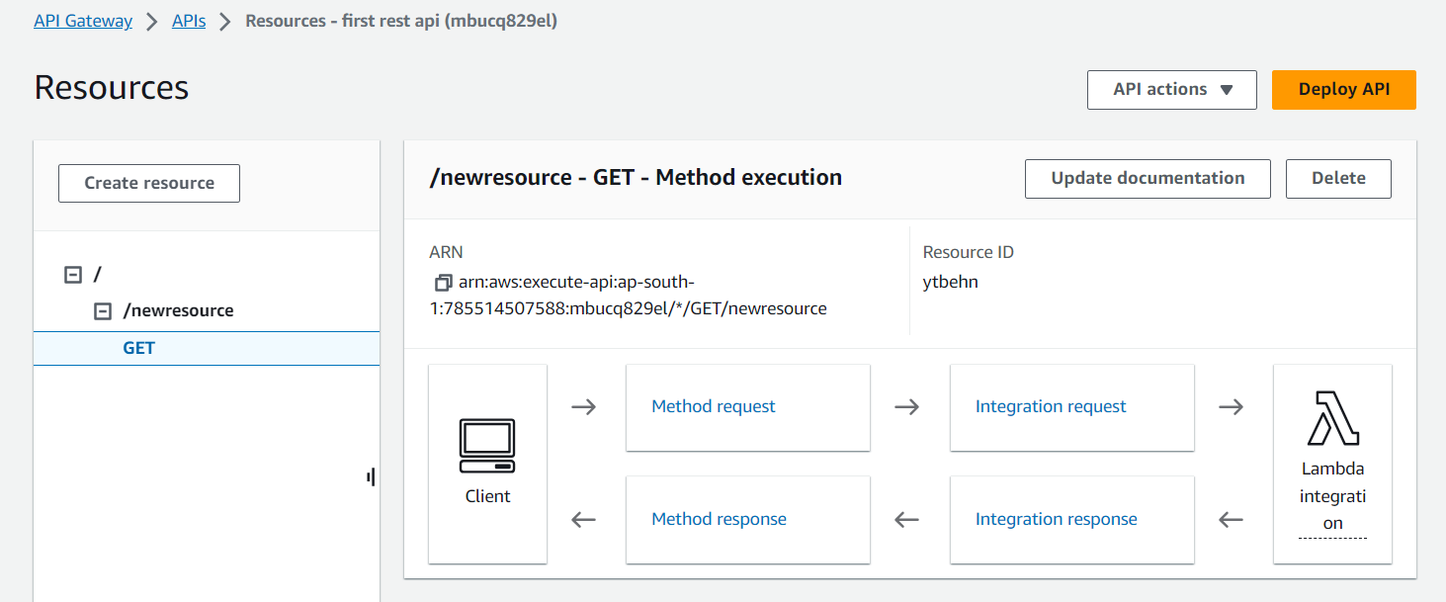

**Deploy Api as below by creating stages as below:**

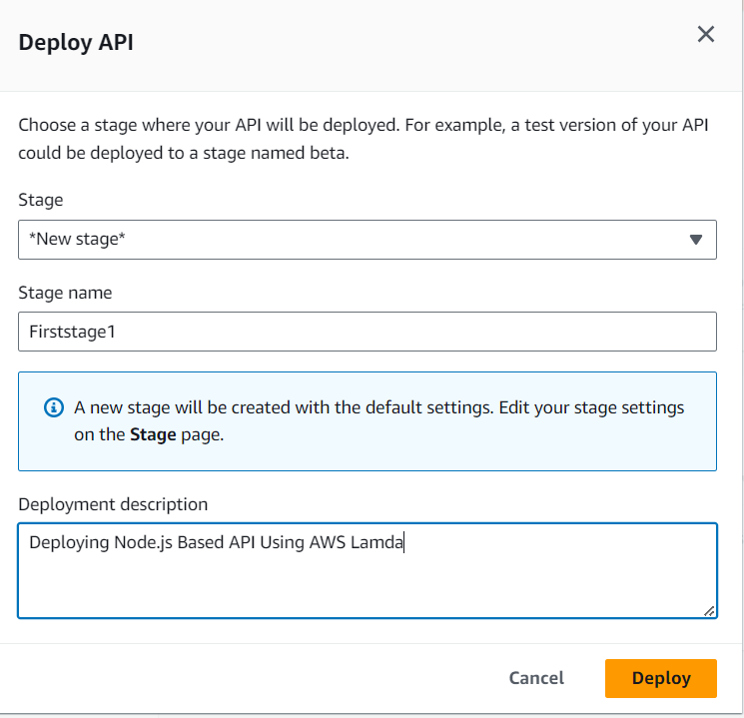

**After deploying api we will get the active status if we got successful result as below:**

**Active Deployment:**

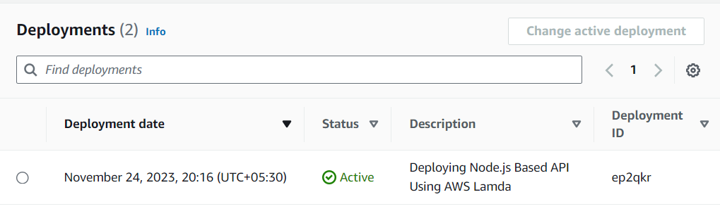

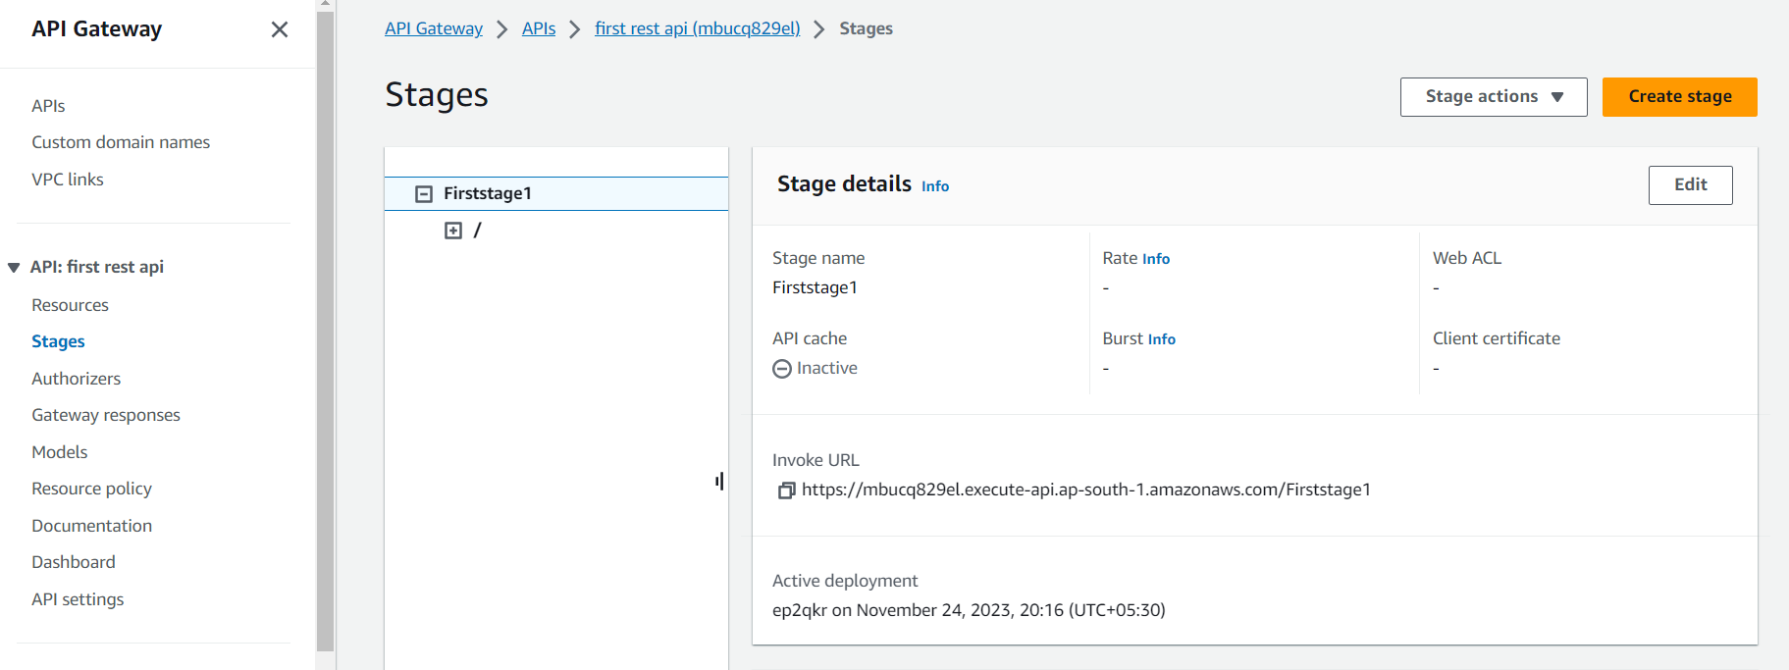

**Test the Api**

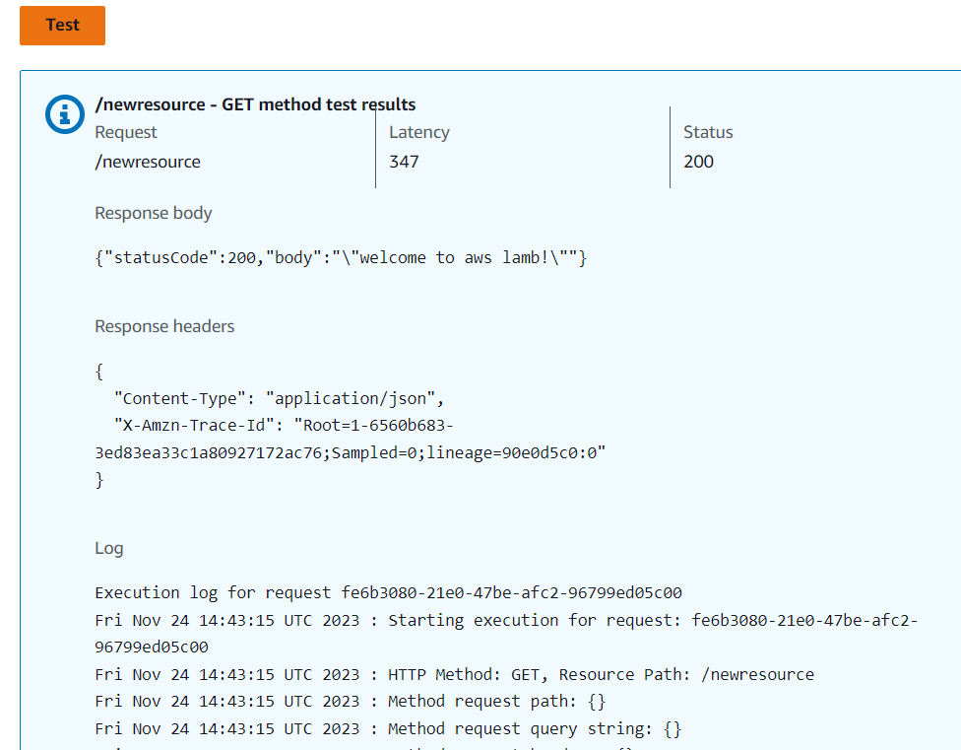

**Invoke Url:**

<https://mbucq829el.execute-api.ap-south-1.amazonaws.com/Firststage1>

By using Postman we can check and test api by using Invoke Url